**Working with Lambda**

Step1:Create two s3 buckets with the name

SS1; Source bucket

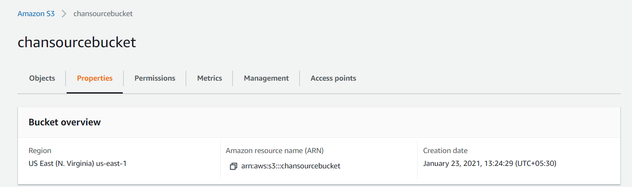

Destination bucket

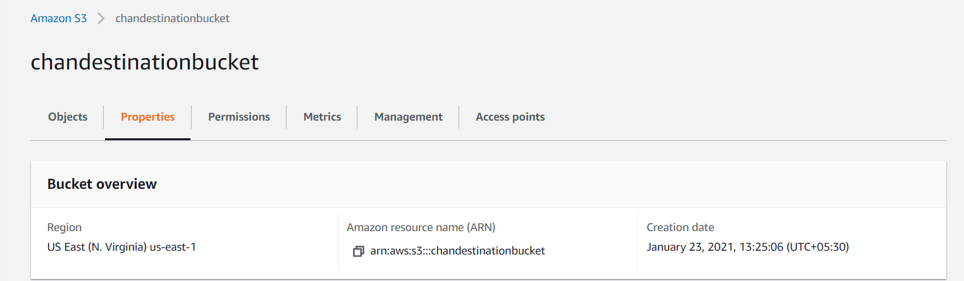

Step2:Creat a policy with limited Read-write permissions using a JSON script

ss2:json script in place

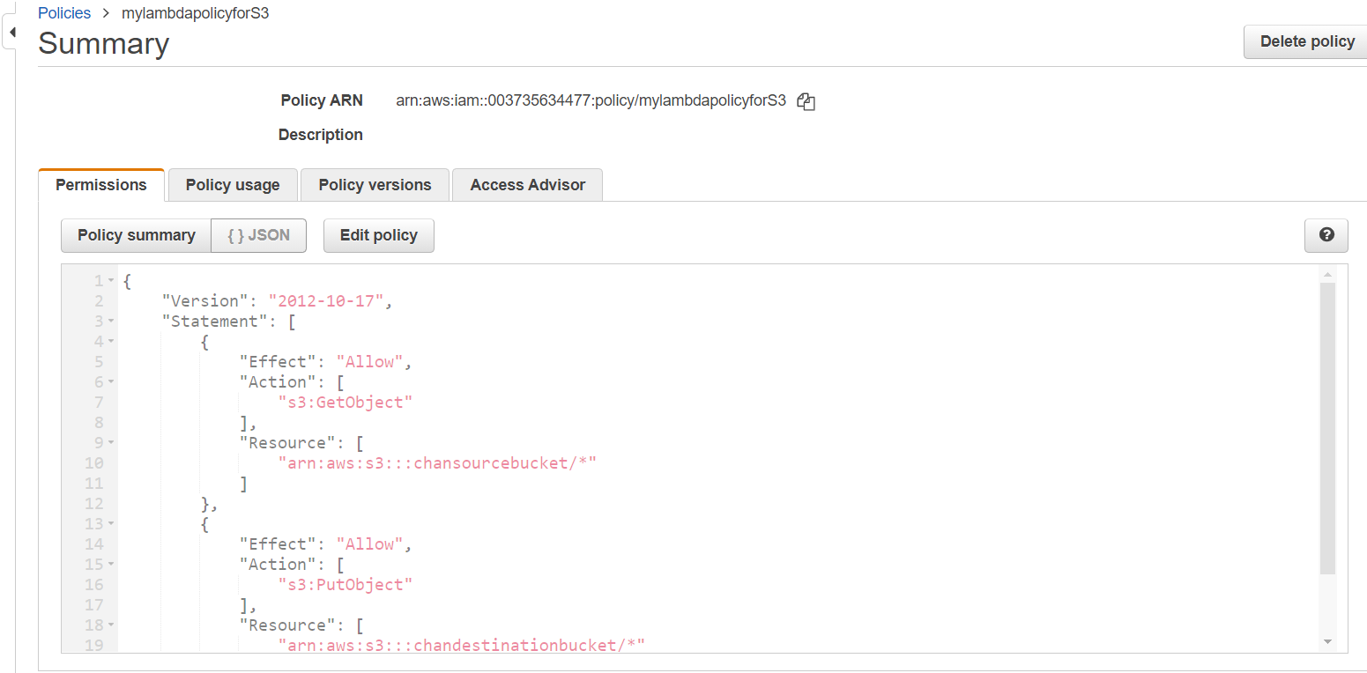

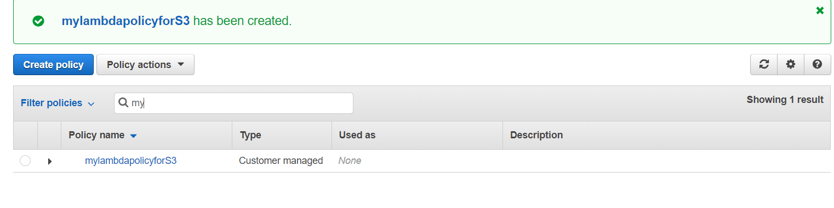

Step3:Create a role and attach the policy

ss4:Role console showing details of the role

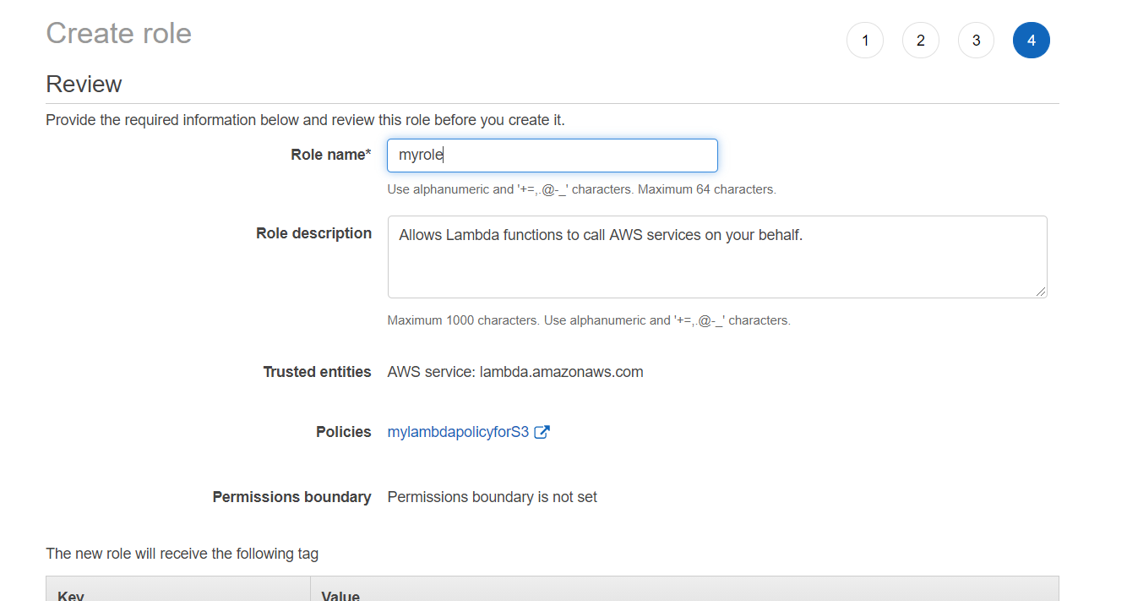

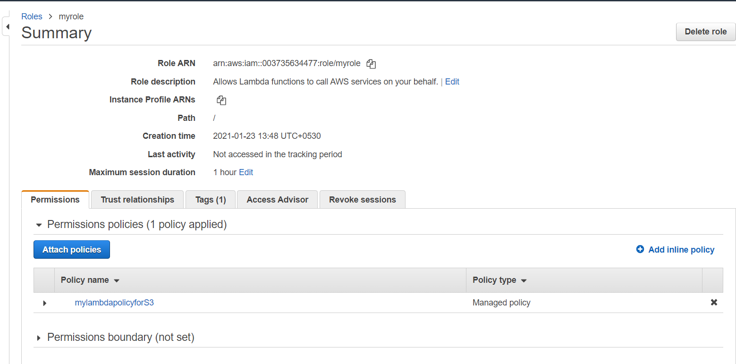

Step4:Create a Lambda function

ss5:lambda functions dashboard

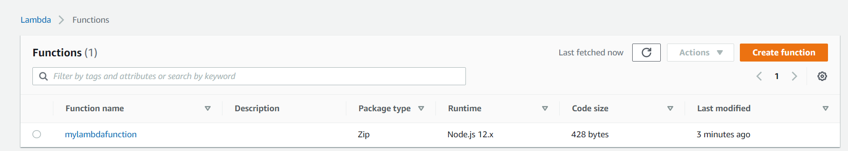

Ss6: js file edited

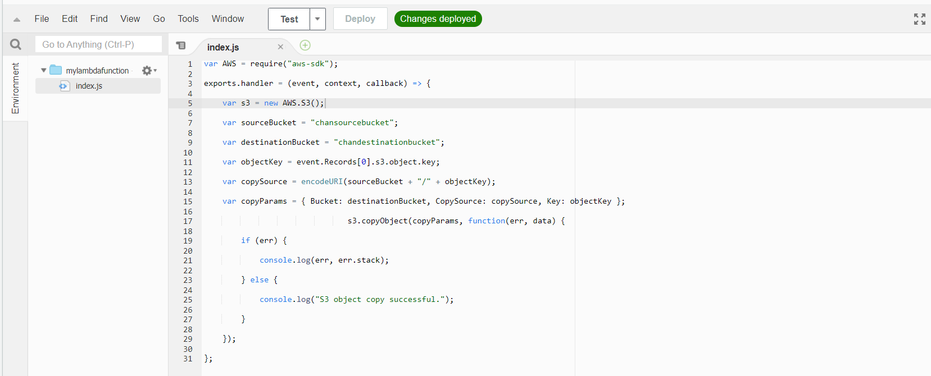

Ss7: adding trigger-s3,bucket name

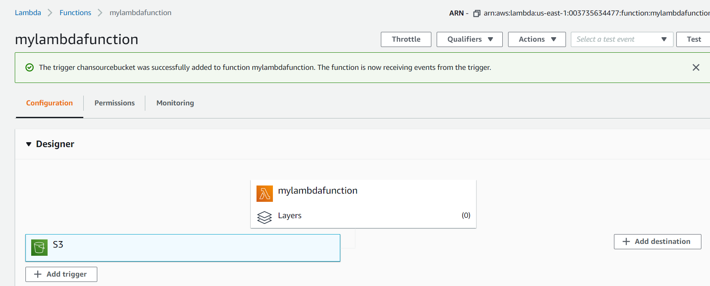

Step6:Test by uploading objects into the source bucket

ss9:object uploaded in the source bucket

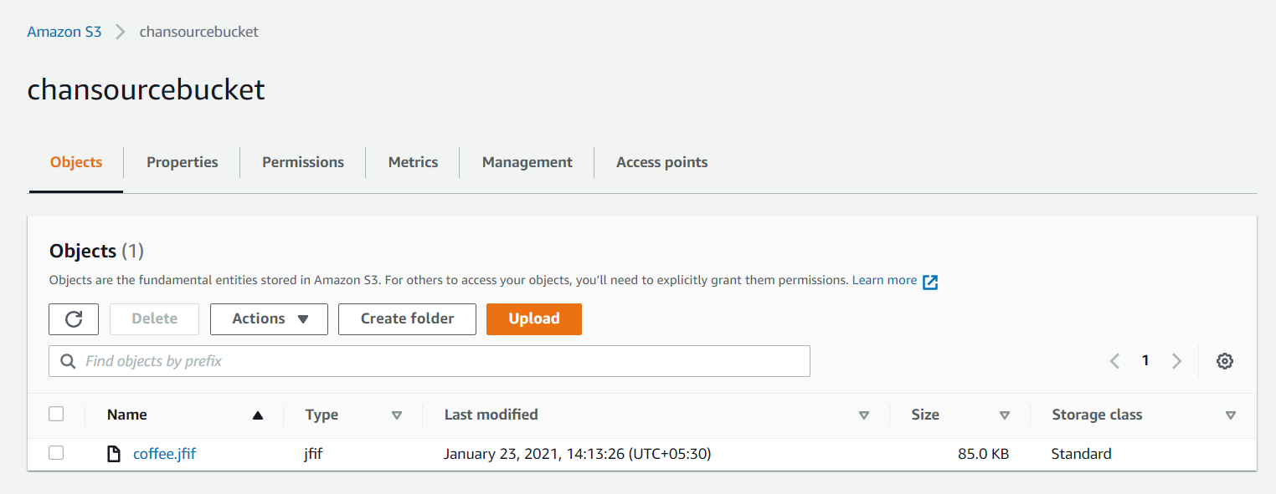

ss10:object replicated in the destination bucket.

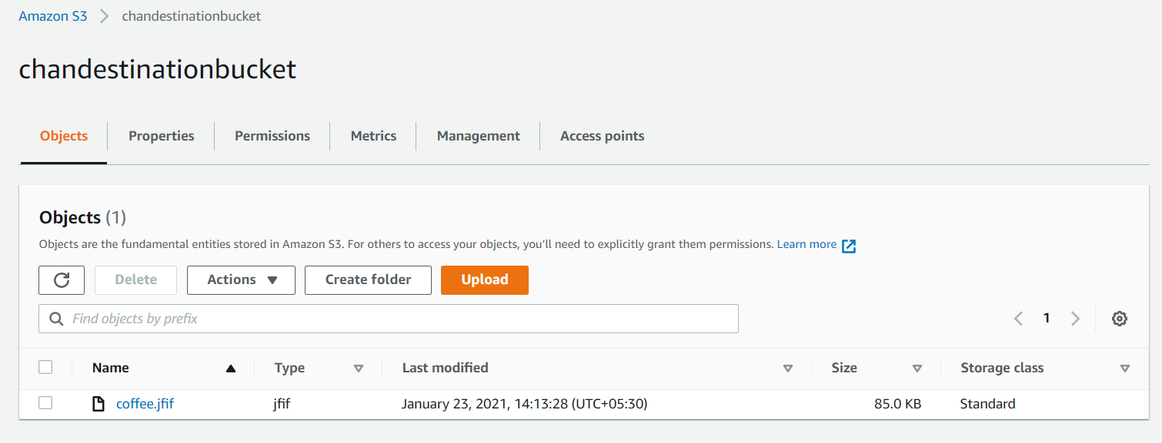

**Working with Elastic container service using fargate**

Step1:Getting started with amazon ECS using fargate

SS1:ECS console

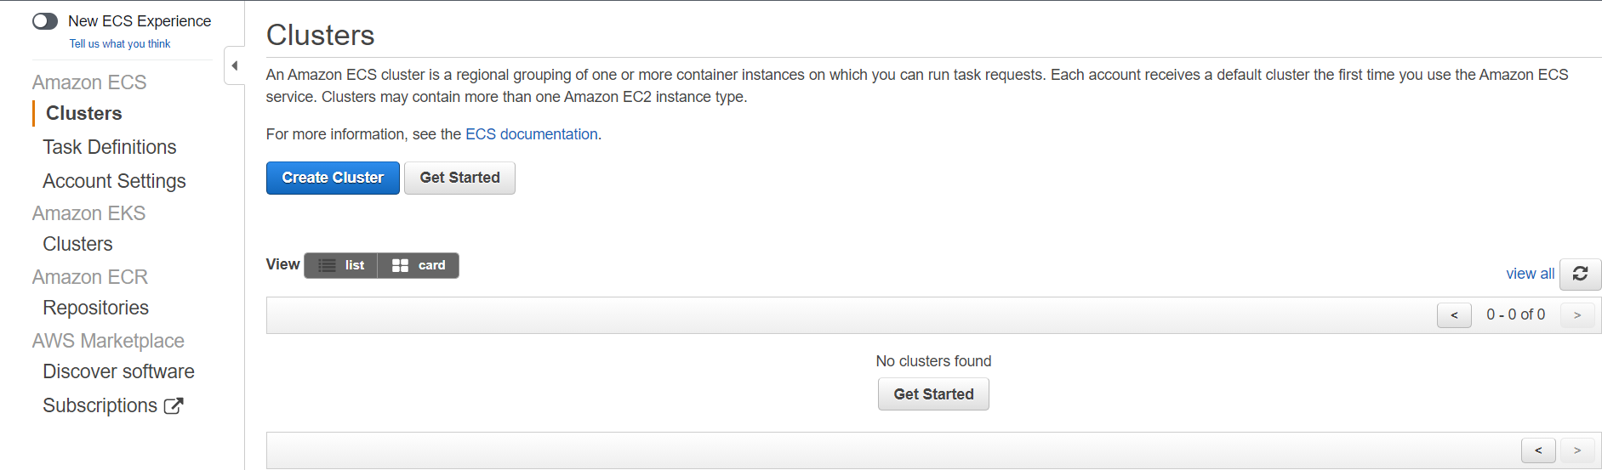

Step2:Creating container and task definition

SS2:2nd panel with all options visible

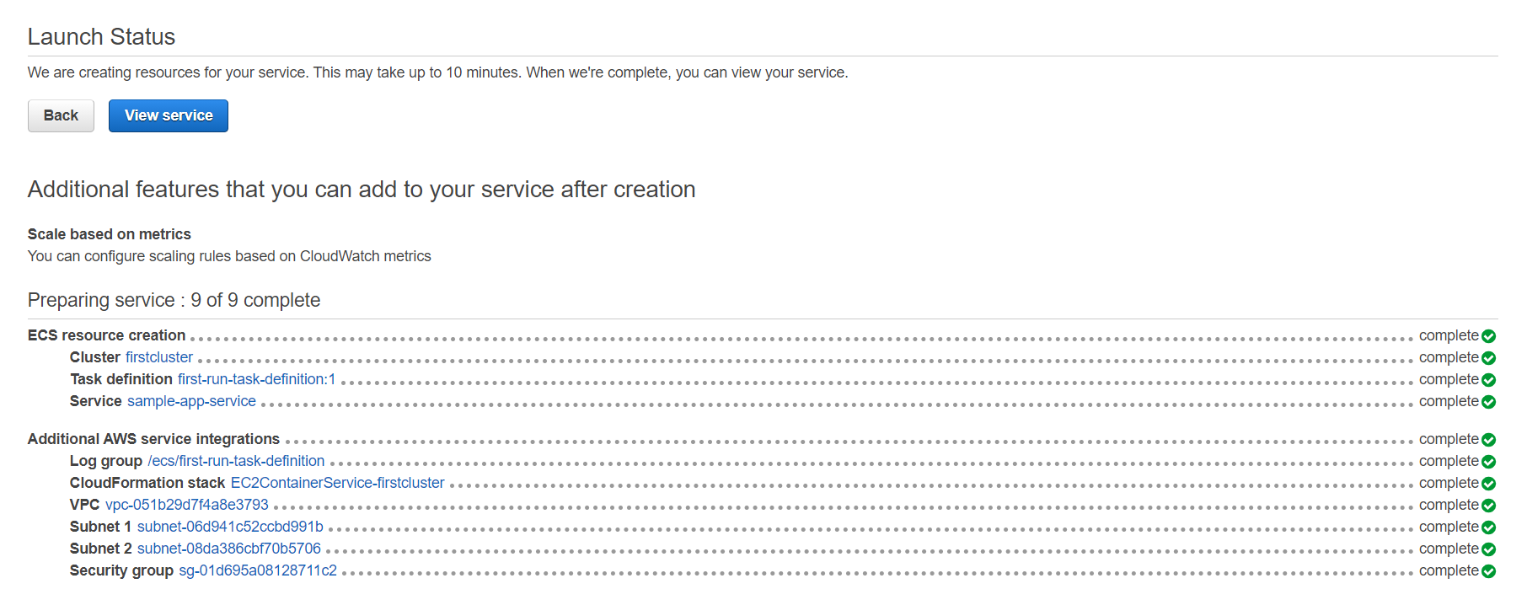

Dashboard displaying the cluster created

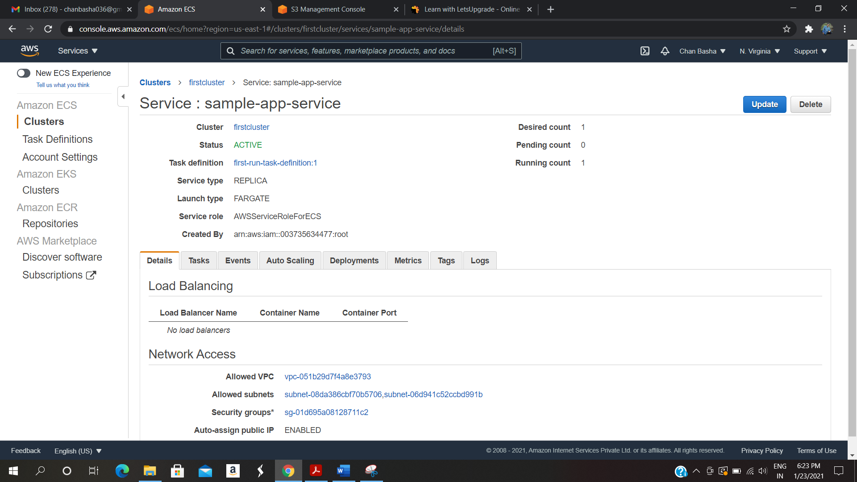

ss7:panel displaying ENI ID

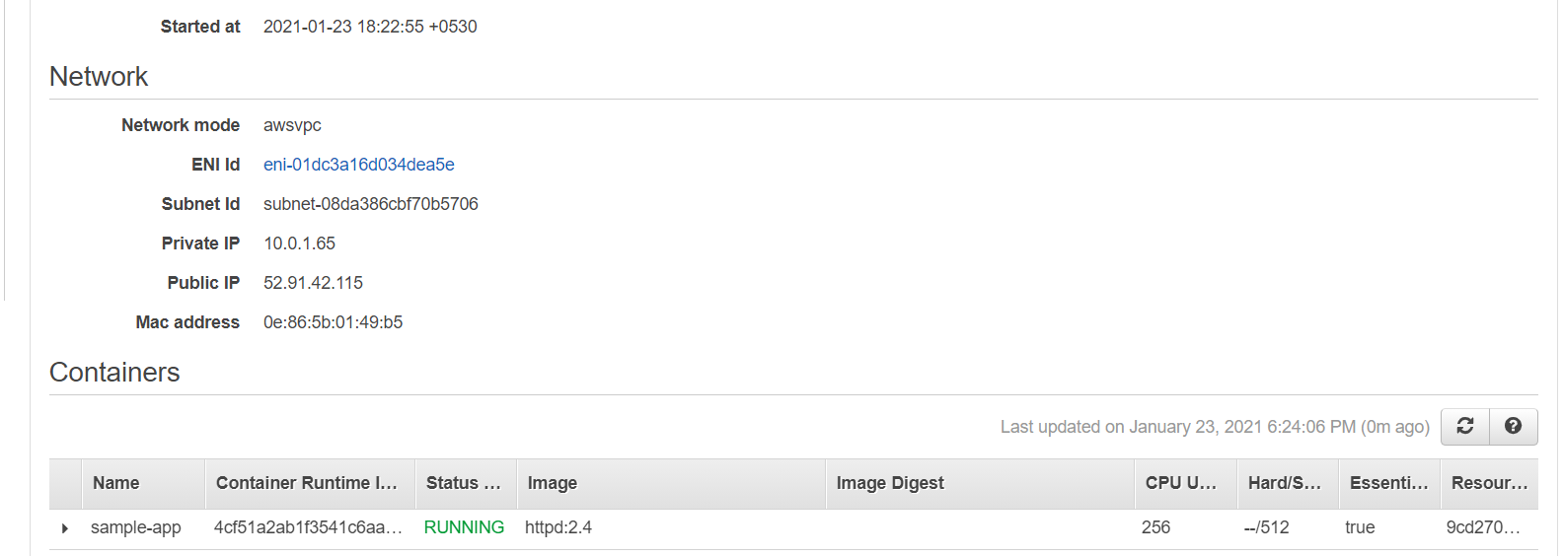

Panel displaying the private, public, and the macid

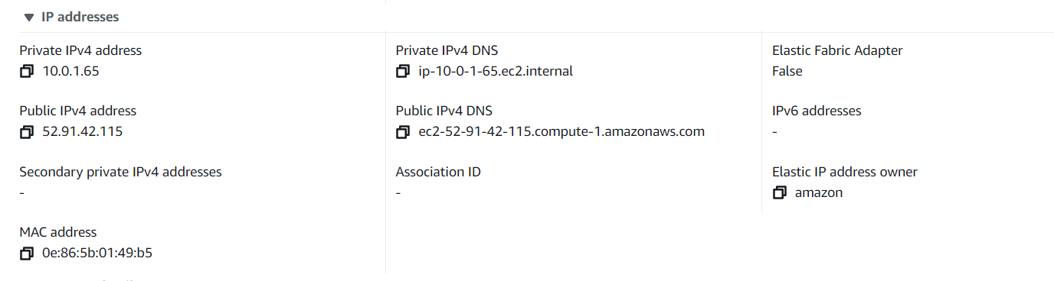

display application

